Copyright reserved

Please turn over



**NATIONAL CERTIFICATE**

**MECHANOTECHNICS N4**

**2021**

**April**

**7**

**This marking guideline consists of 9 pages.**

**MARKING GUIDELINE**

# QUESTION 1

1.1 ▪ Flexible layout ▪ Coordinated service

* Clear transport route
* Optimum use of space
* Accessible service and maintenance points
* Pleasant working conditions
* Minimum handling of materials
* Minimum travelling distance for staff and materials
* One-way flow of materials and products
* Safety of workers and security of equipment (Any 5 × 1) (5)

1.2 ▪ Anodising ▪ Galvanising

* Electroplating
* Phosphating
* Cathodic protection (5)

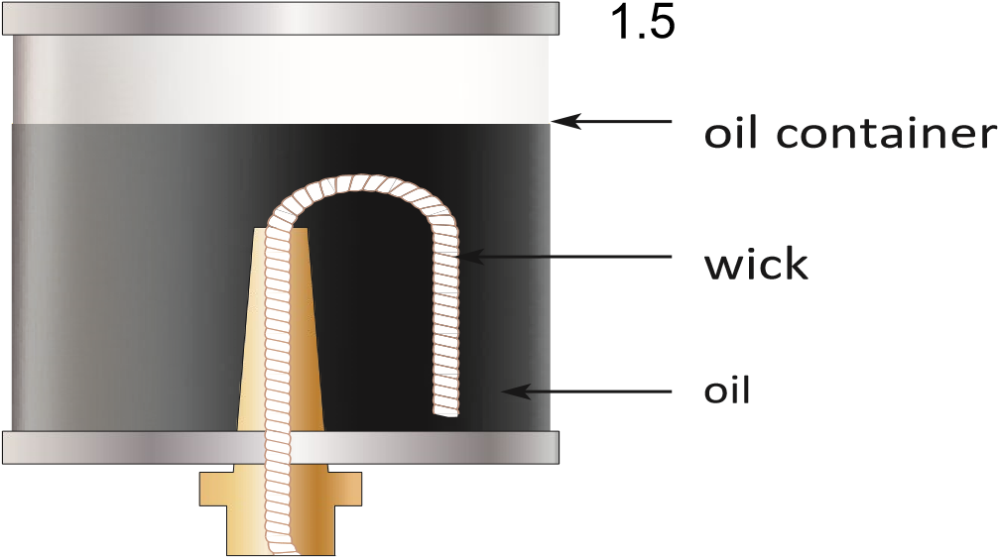

(5)

|  |  |  |
| --- | --- | --- |
| (2 marks for sketch and 3 marks for labelling) |  |  |
|  |  | **[15]** |

# QUESTION 2

2.

1

ø25

mm

58

°

62

°

A

B

*X*

E

F

125

mm

12,5

tan61°= 

*AB*

12,5

*AB*= tan61°

*AB* = 6,929*mm*

*Also*

12,5 tan59°= 

*EF*

12,5

*EF* =  tan59°

*EF* = 7,511*mm*

*EF* =125− *AB*− *EF* −2( )*r*

*EF* =125−6,929−7,511−2(12,5) 

*EF* = 85,56*mm* (8)

2.2

12

,75mm

70

mm

**A**

**B**

**C**

**E**

**D**

|  |  |  |  |  |
| --- | --- | --- | --- | --- |
| *in ABC*∆  *AB*  tanθ=  *AC*  *AB* = 82,75tan30°  = 47,776*mm**in ABD*∆  *AD*  tan30°=   47,776  *AD* = 47,776tan30°  = 27,583*mm*   *Diameter* =2× *AD*  *Diameter* = 2×27,583  = 55,166*mm* | **OR** | *AC* = *AD* +*CD*  *AD*=*r and AD ED*=  *in*∆*CDE*  *ED* sin30°= *CD r*  *CD* =   sin30  = 2*r*   *AC* = *AD* +*CD* 82,75 = +*r* 2*r*  *r* =   = 27,583*mm*   *Diameter* = 2×27,583  = 55,166*mm* |  | (7)  **[15)** |

# QUESTION 3

3.1 *TA* = *TS* + 2*TP*

*TA* = +60 2×20

*TA* =100*teeth*

|  |  |  |  |  |  |
| --- | --- | --- | --- | --- | --- |
| No | Condition | Gear A | Gear P | Gear S | Arm D |
| *1* | *Fix arm D and rotate Gear A by*  *+1rev* | +1√ |  |  | *0* √ |
| *2* | *Multiply by x and add y* | *x* + *y*√ | 5*x* + *y* √ | −1,667*x* + *y*√ | + *y* √ |
| *3* | *NA* = 0  *NS* = 450*r* / min *ND* =? | *NA* = 0√ |  | *NS* = 450√ | *ND* =?√ |
| *4* | *NA* = ?  *NS* = 450*r* / min  *ND* =−15 | *NA* = ?√ |  | *NS* = 450√ | *ND* =−15√ |

*x* + =*y* 0  *x* =−*y*...................1

−1,667*x* + =*y* 450..............2

*substitute* ...1 *in* ....2

−1,667(− + =*y*) *y* 450

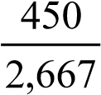

*y* =

*y* =168,729

*ND* =168,729*r* / min *clockwise/positive direction* (11)

3.2  *y* =−15......................1

−1,667*x* + =*y* 450..............2

*substitute* ...1 *in* ....2

−1,667*x* − =15 450

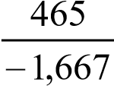

*x* =

*x* =−278,944 

*NA* = +*x y*

*NA* =−278,944 −15

*NA* =−293,944

*N A* = 293,944*r* / min *anti* −*clockwise /opposite direction*

(4)

# [15] QUESTION 4

*De* = +*D t*

*De* =1,2+0,012

*De* =1,212*m* 

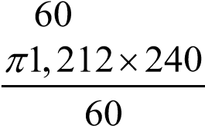 π*D Ne*  *v*=

*v*=

*v* =15,23*m s*/ 

**[5]**

# QUESTION 5

5.1 5.1.1 *f* × ×*l Q*2  *hf* = 5

3,026×*d*

*p*

*hf* =

*Rhoxg*

60 10× 3  *hf* = 

1000 9,81*x*

= 6,116*m*

*hf* ×3,026×*d*5

*f* =

*l*×*Q*2

6,116×3,026×(0,09)5

= 2 

20×(0,03)

= 0,00607 (5)

5.1.2 *d*  *m*=

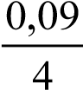 4

=

= 0,023 (2)

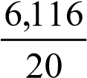 5.1.3 *hf*   *i* = *l*

=

= 0,306 (2)

5.1.4 *v* π*d*2

*C* =  *A* = 4

*Q* π(0,09)2  *v* = = √

*mi*

*A* 4

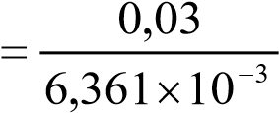

√= 6,361 10*x* −3*m*2

= 4,716*m s*/  *v*

*C* =

*mi*

0,023

0,306

4,716

×

=

= 56,215 (5)

5.2 π*D*2

*A* =

4

π0,182 *A* =

4

*A* = 0,025*m*2 

*D*4

2

*m* = 4

*d*

0,184

2

*m* = 4

0,11 *m*2 = 7,170 

*h* =12,6*h*1

*h* =12,6(0,86) *h* =10,836*m*

*Q C A*= *d* × ×

*Q*= 0,97×0,025×

2

2

(

1)

*gh*

*m*

−

2(9,81)10,836

(7,170

1)

×

−





*Q* = 0,142*m*3 / *s*  (6)

# [20] QUESTION 6

6.1 • Fluctuating stepped load

* Linear fluctuating load
* Sinusoidal fluctuating load
* Continuously fluctuating load (Any 3 × 1) (3)

6.2

*F*

*F*

1

*F*

2

*F*

*m*

*F*

*n*

*n*

1

*t*

1

*n*

2

*t*

2

*n*

*n*

*t*

*n*

*F*

*F*

(

t

)

*F*

*m*

0

*t*

0

2

*t*

0

*t*

Fluctuating Stepped Load Continuously fluctuating load

*F*

*F*

*min*

*F*

*m*

*F*

*max*

*F*

*F*

*m*

*F*

*max*

Linear fluctuating load Sinusoidal fluctuating load (12)

**[15]**

# QUESTION 7

7.1 *Ff*  µ= *N R*

*Ff* =µ× *N R*

= 0,02×80 10× 3

=1600*N*  π. .*DN* *v*=

60

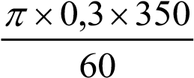 =

= 5,498*m s*/ 

*Pf* = *Ff* ×*v*

=1600×5,498 

= 8796,8*W*  (6)

7.2 7.2.1 2π*NT*

*P* =

60

*P*×60

*T* =

2× ×π *N*

3,5 10× 3 ×60

= 

2 1750π

=19,098*N m*. 

7.2.2 *PO*

η= ×100

*P*1

*PO* = *Pi* ×η

= 3,5 10× 3 ×0,8

= 2800*W* 

*P*×60

*T* = 2× ×π *N*

=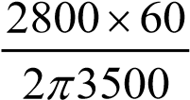

= 7,63*N m*. 

7.2.3 *P*×60

*T* = 2× ×π *N*

=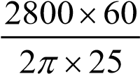

=1069,521 .*N m*

(3 × 3) (9)

**[15]**

# TOTAL: 100